**Lab2**

**(Git, GitHub, ML)**

Step 1: Install git in your local machine (If it is already done, skip this step)

**ALREADY DONE**

Step 2: Build a ML model for Breast Cancer Wisconsin (Diagnostic) Data set in jupyter notebook. <https://archive.ics.uci.edu/ml/datasets/breast+cancer+wisconsin+(diagnostic>)

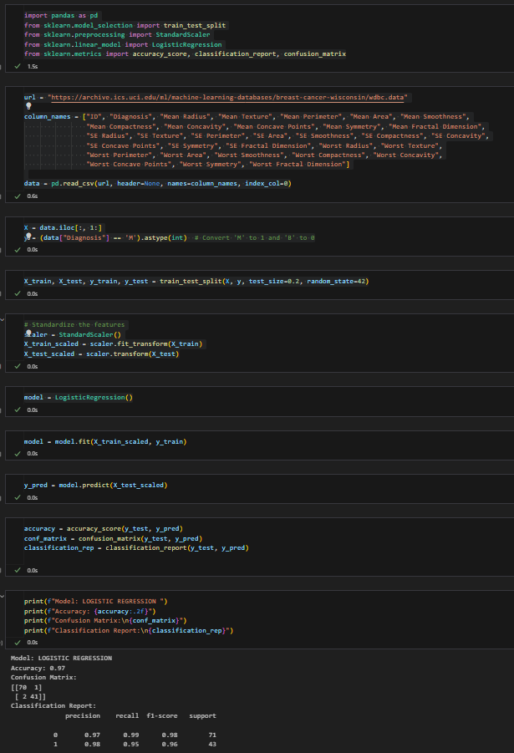

Step 3: Please provide screenshots for various stages of the design process (importing data, training, evaluation …)

**IMPORTING**

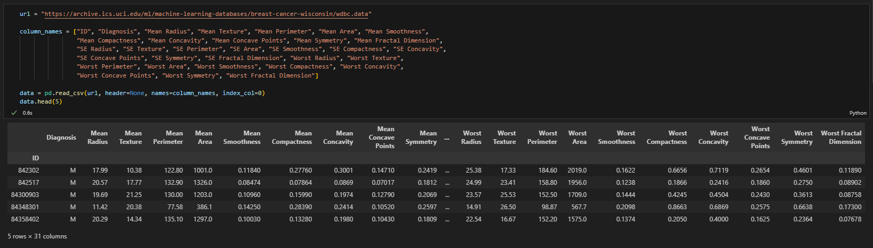

**TRAINING**

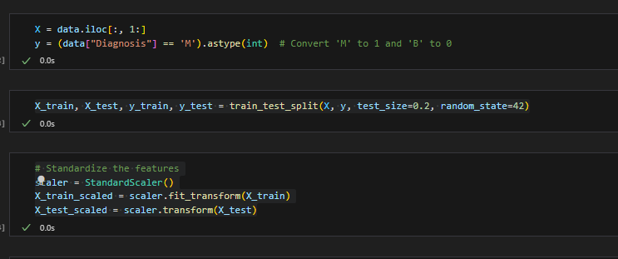

**EVALUATION**

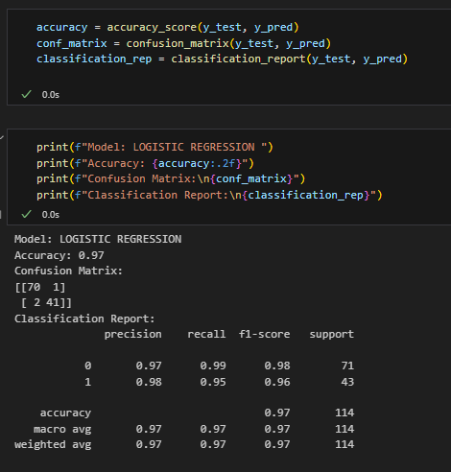

Step 4: Upload your model (Python script, let’s called it <yourname>_model_v1) to GitHub. Provide screenshot of all your git commands and your command prompt showing success of commit of your model files in the remote host.

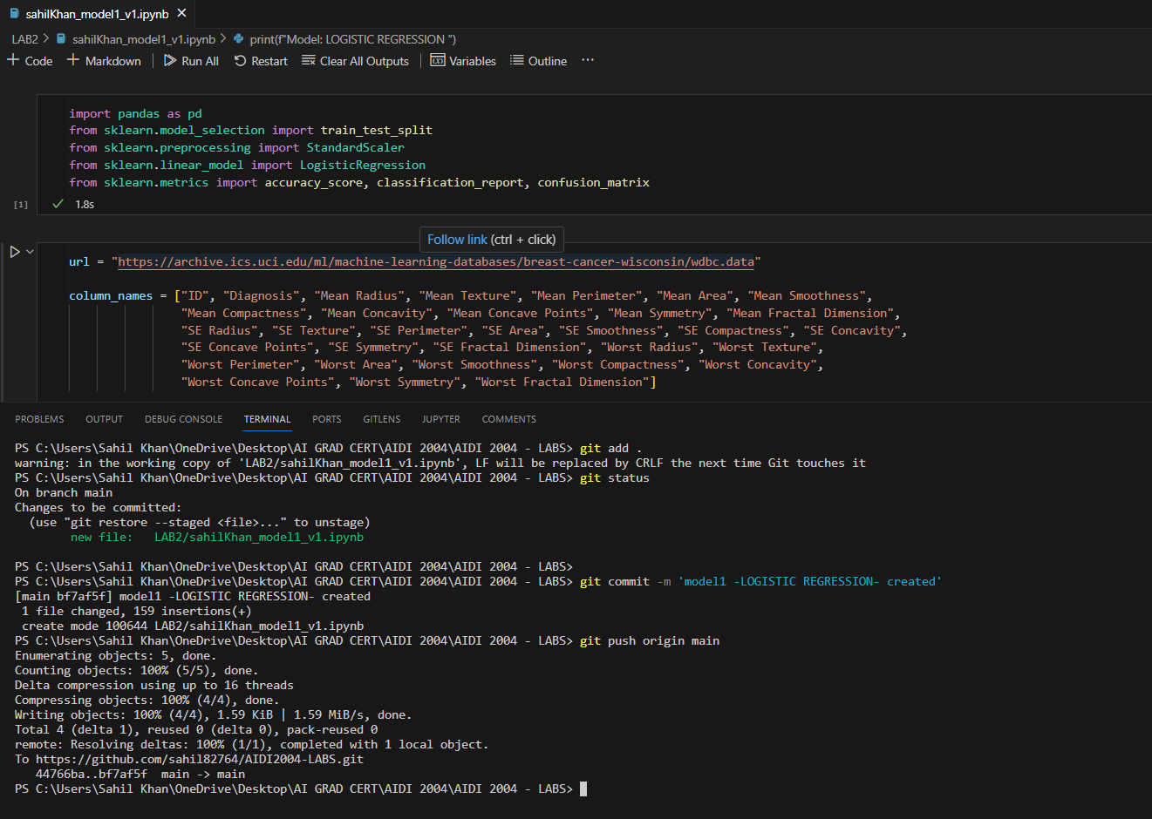

Step 5: Create a branch in your repo and upload another ML model (may be using a different algorithm and named the file: <yourname>_model_v2) of your choice for the same dataset into that branch.

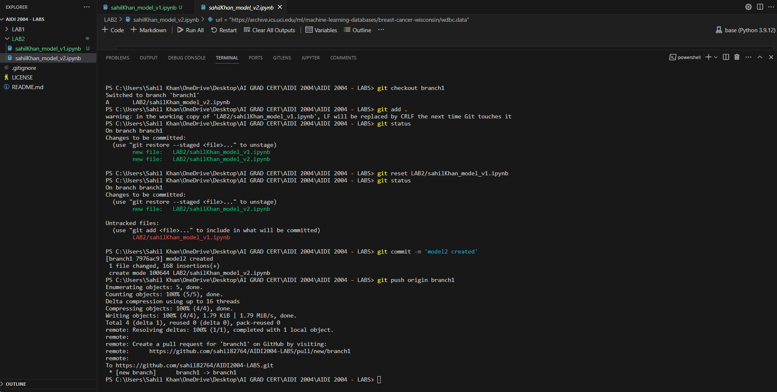

Step 6: Navigate to your newly created branch and provide screenshot showing status of your repo.

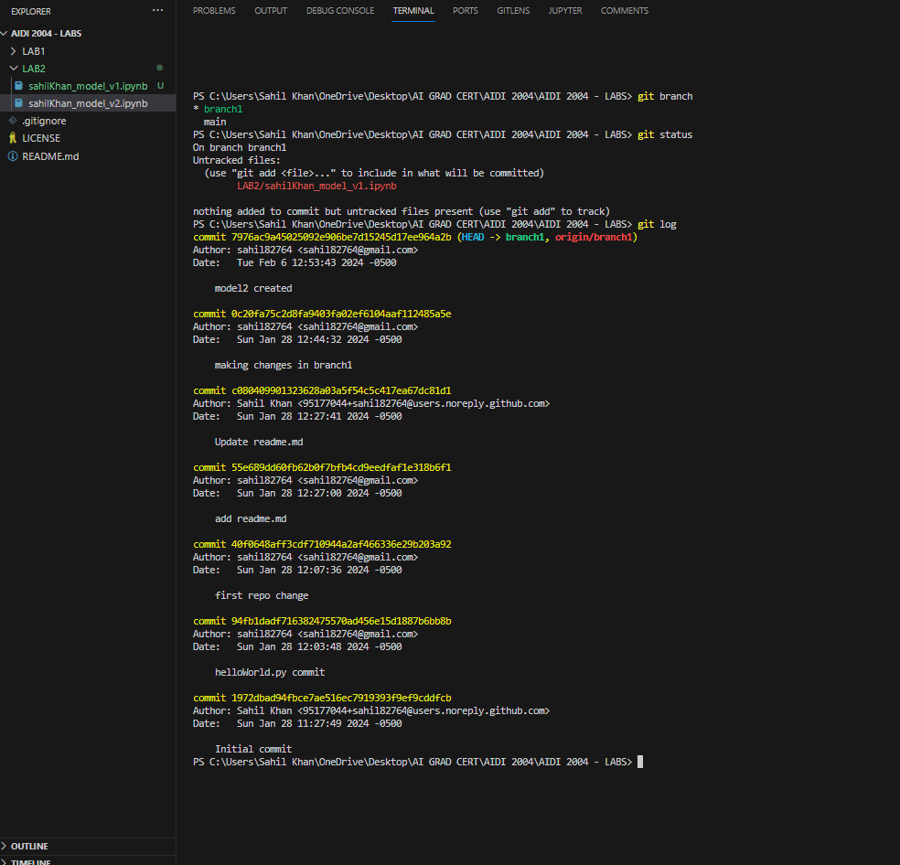

Step 7: Provide a screenshot showing your log of activities and perform your final commit.

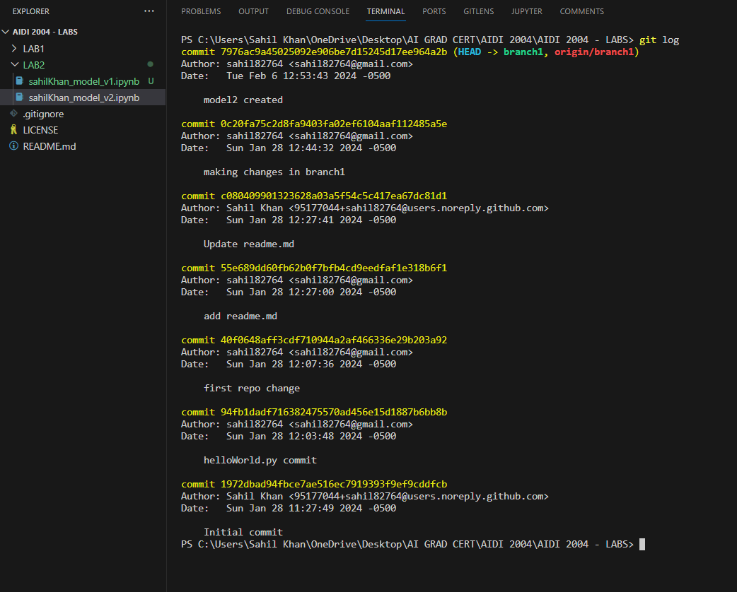

Step 8: Provide a description of your program in the README.md file.

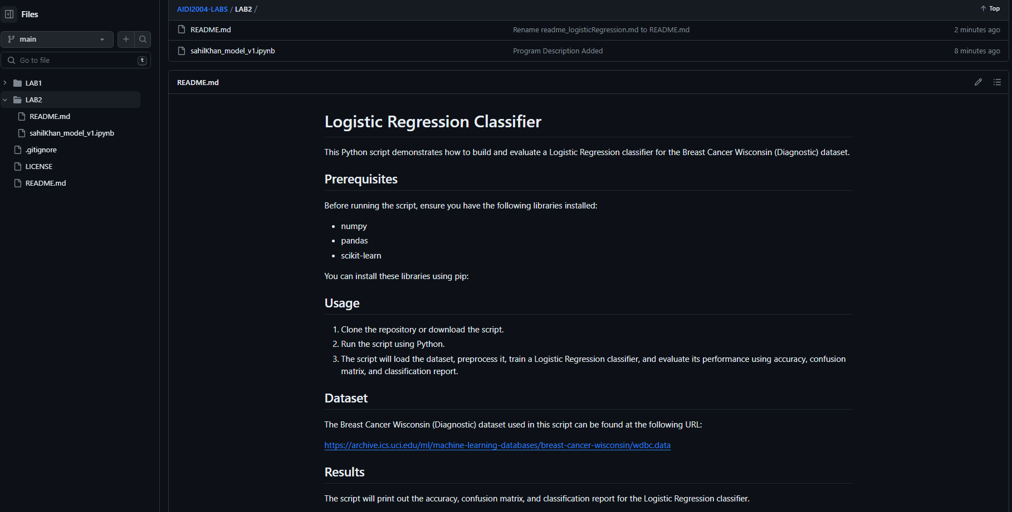

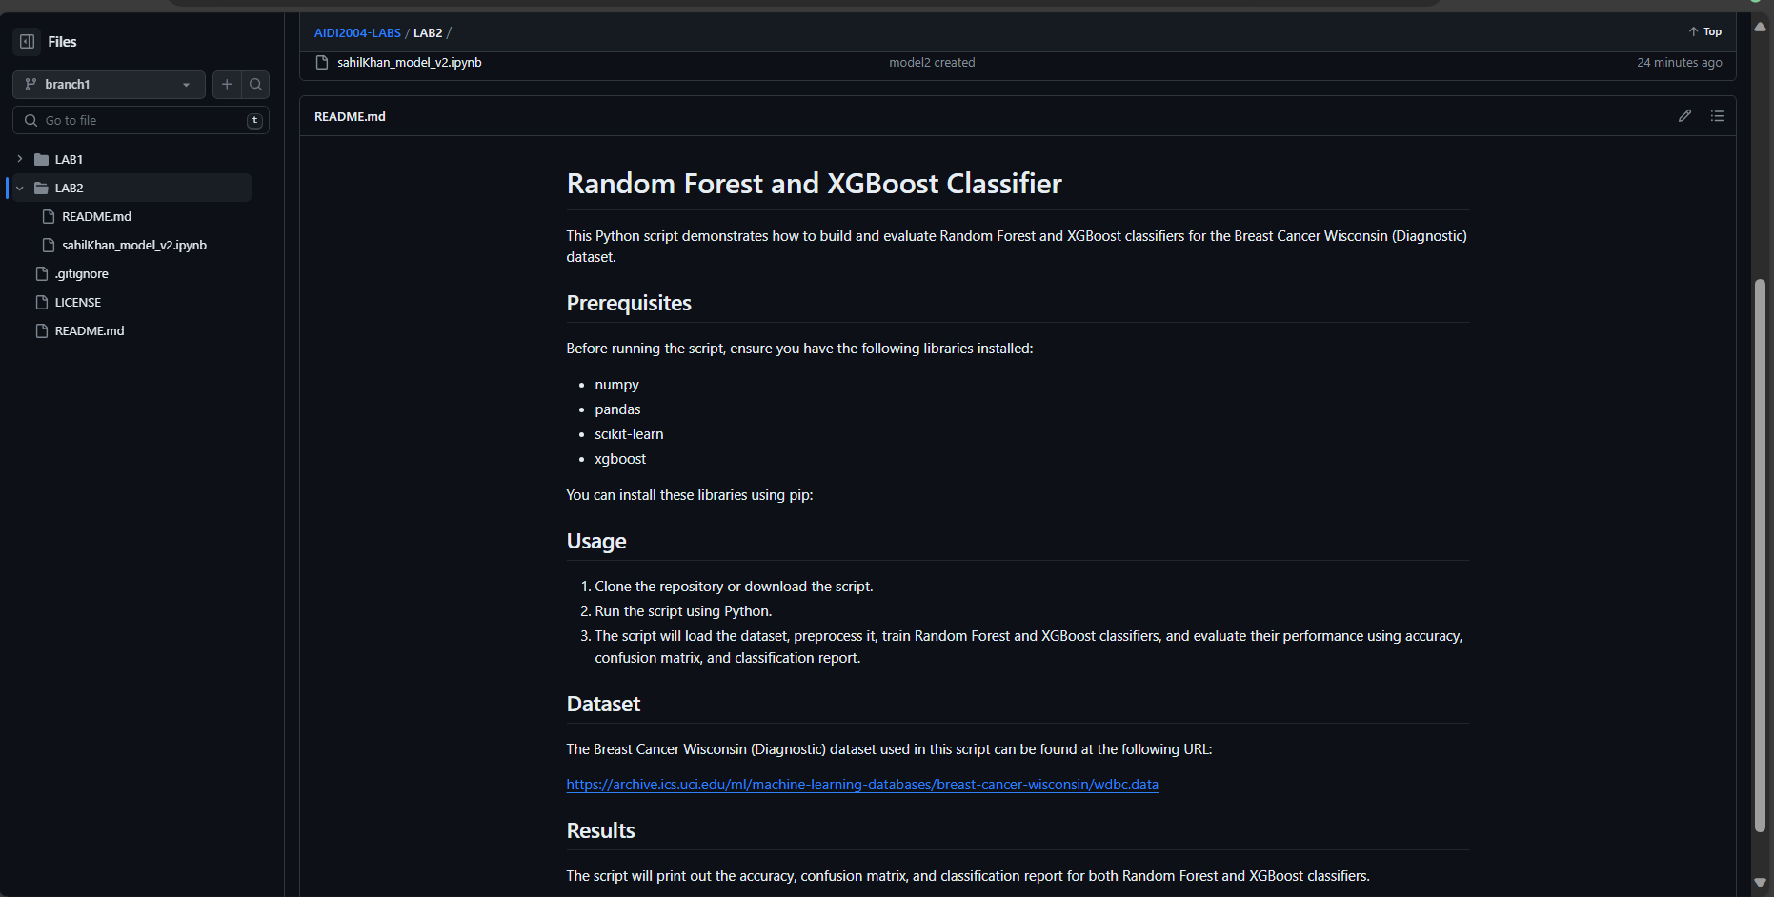

**Step 9: Make your repo public and share the link of your repo for check.**

[**sahil82764/AIDI2004-LABS (github.com)**](https://github.com/sahil82764/AIDI2004-LABS)

[**https://github.com/sahil82764/AIDI2004-LABS**](https://github.com/sahil82764/AIDI2004-LABS)